***Cloud Based Collaborative WhiteBoard***

***(Assignment-2)***

**NAME : KHYATHI SUSMITHA KAMIREDDY**

**ID NUMBER : 199046929**

**MODULE : Internet and Cloud Computing**

**MODULE CODE : CO3219/CO4219/CO7219**

**COURSE : MSc Cloud Computing**

**SUBMITION DATE : 10/12/2020**

**Introduction**

Project development entails a collaborative whiteboard system that allows many learners to have the ability to log in and create concurrent drawings which is being done on the white board platform. The whiteboard based in the cloud enables the different users to connect and they are able to receive updates basing on the actual time and when it comes to the condition of the connections it is consistent. When it comes to this application it is utilized for various purposes, for instance when it comes to teaching the users connected to the system will have to pick a leader who plays the role of upgrading the rights which includes the right of deleting users out of the service system (Bache *et al.* 2020).

**Distributed System Design Architecture**

When this system was developed it initiated the utilization of the client server architecture. In this system, the users are brought together by a connection done through the server and the platform of the client. The user makes use of the client platform and in order for the connections to take place the user in collaboration with the services of the client have to make a request for the connections on the server. When the request is successful the server receives the connection which includes the log in credentials for the user. After the connections have taken place the server confirms the log in appeal and ensures that the user is a member of the class found on the system platform (Du, Li and Varshney, 2019). When the server confirms the validation it will be able to give a feedback that will permit the user to have full access to the system. Also this will enable the user to acquire the services being provided on the server through the client platform and other users will be able to log in to the connection on the whiteboard, these connections are carried out on the sockets which leads to multi-threading technology which allows the users to log into the system (Jolak, Vesin and Chaudron,2017). The server architecture has the consistency, scalability and the performance of the system is reliable.

**Distributed State Management**

This system permits the users to access the system assisting them to create their drawings in a simultaneous way. This system is successful since the multithreading technology is included in to the system, a trend is being created in every connection found in the system enabling transactions to take place in the server through the sockets simultaneously without no glitch occurring. New users are able to log in to the system without any hindrance since they are able to utilize a different threading. The features that are found in the system commences its actions from the server, this enables the users to view the images drawn on the whiteboard (Fast-Berglund, Harlin and Åkerman, 2016). The activities taken into action by the clients when viewing the image has the reflection on the actual time basing on the other users using the system platform.

**Salient Design Features**

The whiteboard system has the following features when it comes to drawing (Sun, 2016);

1. An Eraser which can be utilized to rub the drawings when the user makes an error.
2. A line that can be used to make drawings that are complete since most shapes and drawings rely on this feature.
3. Zoom which is utilized to adjust the images when the sizes are increased inwards and outwards.
4. Pencil used to create the drawings.
5. Hand that is utilized for holding and moving the drawing from one position to another.
6. Ellipse that is utilized to present the lines that has dots on their drawings.
7. The Cursor that is used to point out the drawings and it is able to show the position that the drawings are found at in the current position.
8. Rectangle used to draw shapes that are rectangular on the whiteboard and adjustments can be carried out to enable the creation of the four edged shapes.
9. Text helps to make the textual drawing found on the whiteboard.

**Technology choices made**

In order for the design and the system to be developed, the technologies below were considered and utilized;

* The programming in the socket is utilized by users who are connected on the server by the use of <http://localhost:3000>.

**Service Implementation details**

The implementation of the Docker service program is illustrated in the below code;

|  |
| --- |
| var applicationjs = require('../app');  var cleandebug = require('debug')('drawing-tool:server');  var hyprotocol = require('http');  var apport = normalizePort(process.env.PORT || '3000');  applicationjs.set('port', apport);  var servicenum = hyprotocol.createServer(applicationjs);  servicenum.listen(apport);  servicenum.on('error', onError);  servicenum.on('listening', onListening);  var io = applicationjs.io;  io.attach(servicenum);  function normalizePort(val) {  var apport = parseInt(val, 10);  if (isNaN(apport)) {  return val;  }  if (apport >= 0) {  return apport;  }  return false;  }  function onError(error) {  if (error.syscall !== 'listen') {  throw error;  }  var bind = typeof apport === 'string'  ? 'Pipe ' + apport  : 'Port ' + apport;  switch (error.code) {  case 'EACCES':  console.error(bind + ' requires elevated privileges');  process.exit(1);  break;  case 'EADDRINUSE':  console.error(bind + ' is already in use');  process.exit(1);  break;  default:  throw error;  }  }  function onListening() {  var addr = servicenum.address();  var bind = typeof addr === 'string'  ? 'pipe ' + addr  : 'port ' + addr.apport;  cleandebug('Listening on ' + bind);  } |

**Snapshots**

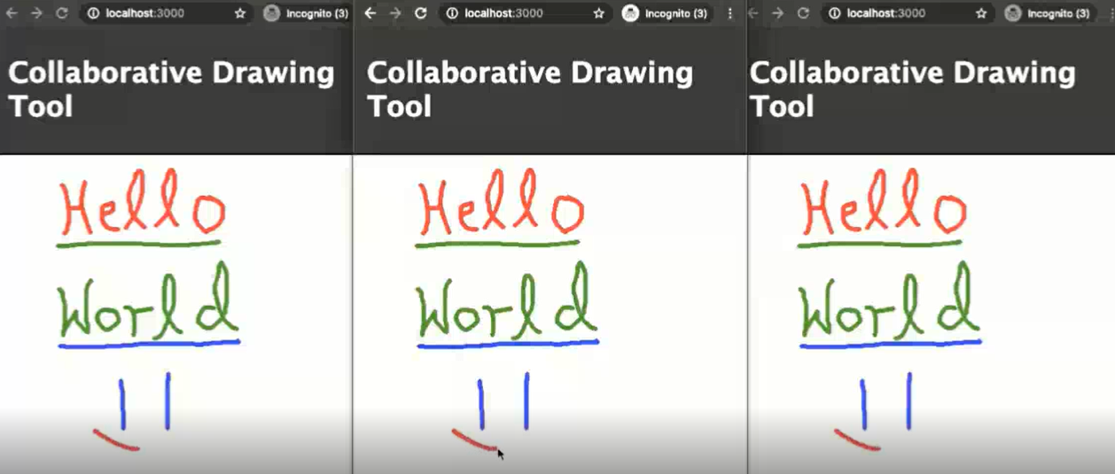

**Conclusion**

In conclusion, whiteboard system that is developed contains the primary features that are necessary for creating the drawings on the white board system platform.

**References**

Bache, V.K.A., Bera, J., Ekambaram, V. and Sadacharam, S., International Business Machines Corp, 2020. Converting whiteboard images to personalized wireframes. U.S. Patent 10,691,429.

Du, R., Li, D. and Varshney, A., 2019, May. Geollery: A mixed reality social media platform. In Proceedings of the 2019 CHI Conference on Human Factors in Computing Systems (pp. 1-13).

Fast-Berglund, Å., Harlin, U. and Åkerman, M., 2016. Digitalisation of meetings–from white-boards to smart-boards. Procedia CIRP, 41, pp.1125-1130.

Jolak, R., Vesin, B. and Chaudron, M.R., 2017. Using Voice Commands for UML Modelling Support on Interactive Whiteboards: Insights and Experiences. In CIbSE (pp. 85-98).

Sun, X., 2016, February. Design and Implementation of Whiteboard in Online Classroom. In The fourth International Conference on Information Science and Cloud Computing (Vol. 264, pp. 056). SISSA Medialab**.**